**Lesson 4 Demo 6**

**Managing Container Resources**



Steps to be followed:

1. Adding resource limits configuration entries to the pod

**Step 1: Adding resource limit configuration entries to the pod**

1. Navigate to the **deployments** folder and open **facebookdeployment.yaml** file:

***cd deployments***

***vi facebookdeployment.yaml***

1. Add the following code under **spec>>template>>spec>>containers**:

***resources:***

***requests: # Minimum Value***

***memory: "100Mi"***

***cpu: "250m"***

***limits: #Maximum Value***

***memory: "128Mi"***

***cpu: "300m" # 1 Core = 1000m***

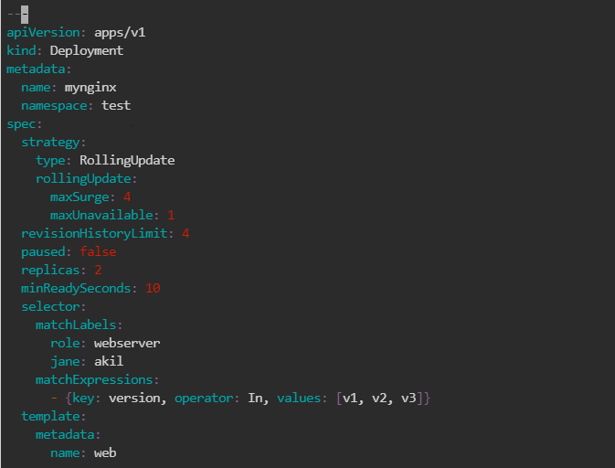

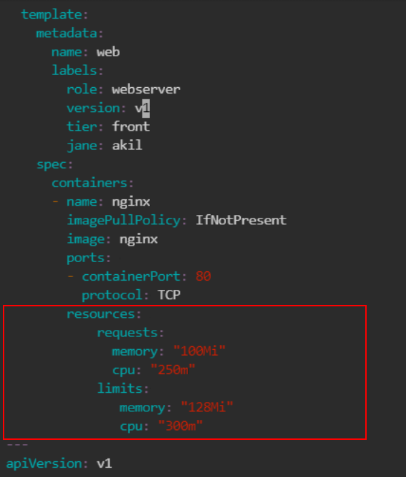

| **Note:** Press the **esc** button and type **:wq** to save and exit the file. |
| --- |

1. Execute this command to create a pod in the specified namespace:

***kubectl apply -f facebookdeployment.yaml -n test***



1. To get the status of deployment in test namespace, execute the following command:

***kubectl get all -n test***

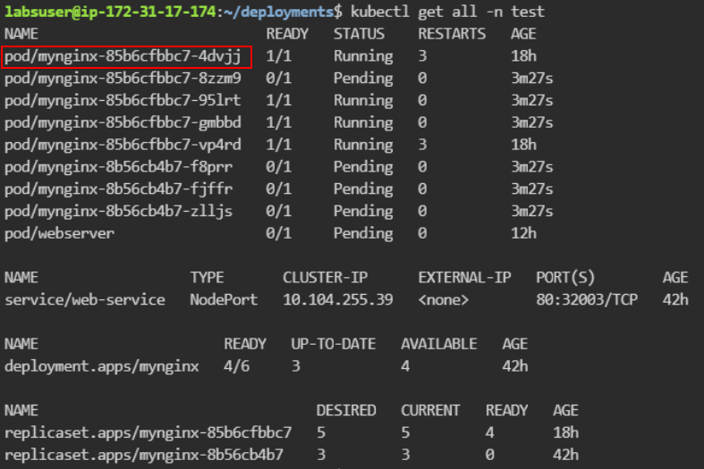

| **Note:** Copy and keep any one of the running pod names for executing the next step. |
| --- |

1. Execute the command to check the details of the pod created and the resources defined:

***kubectl describe pod <<podname>> -n test***

***Eg: kubectl describe pod mynginx-85b6cfbbc7-4dvjj -n test***

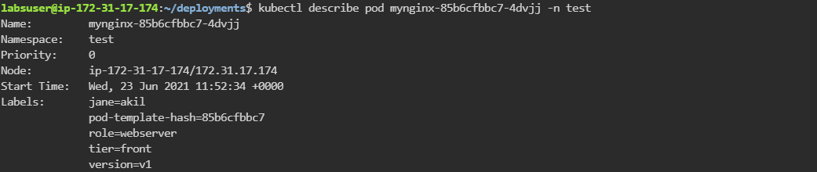

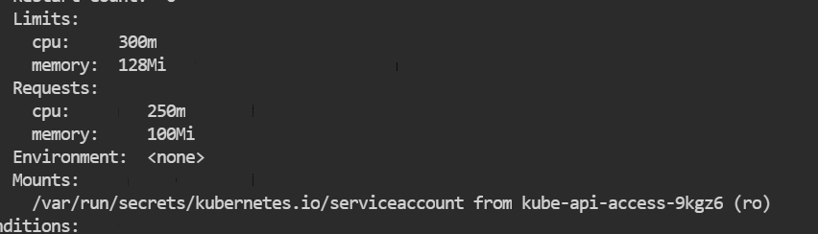

| **Note:** The resource entries can be found in the above screenshot. |
| --- |